Archetype/Angel, Complex/Dæmon

**The 1 in archetypal and complex forms, Enneagram correspondences**

Course document for August 26, 2015—Deicidus, Internet School of Magic

*As always, please leave questions and comments in the document if you do not mind sharing them with other students (Ctrl-Alt-M). This makes it much faster and easier for me to answer the questions, in-context. This document will be publically viewable.*

The splitting of elements into their constituent sub-elements is an art of the imagination. This week I will explore the differences between angels and demons, the differences and similarities between the Enneagram, Numogram, and Vortex Math systems (in the most cursory/superficial way), and will use the 1 to illustrate these differences and modes of splitting.

# Archetypes & Complexes

These are Jung’s terms for certain psychological constructs. Archetypes are transpersonal, timeless, fundamental patterns which underlie the workings of the psyche and which come pre-packaged with deep mythic images that describe, articulate, and interact with these basic laws of the psyche. Complexes are an instantiation[1] of an archetype in time as a firing and connecting pattern of neurons in the brain—they are an “active” or “living” clone of an archetypal DNA. Jung’s usage of archetype and complex can roughly correspond with the way occultists use the words “god” and “demon”:

| **Jung’s Usage** | **Similar Occult Usage** |
| --- | --- |
| Archetype | God, Archangel, Angel |
| Complex | Demon, Fallen Angel, entity, (sometimes ‘spirit’ generally) |

If complexes are the living creature made from archetypal blueprint, then we can see why demons are “fallen angels” (they fell into time) or why we say that gods sent “messengers” or have an “archangel” whom you interact with more often than the full godform. These spirits are personality-experience firing patterns, games or modes of neuronal activity which organize the rhizomatic neural structure in a certain way over time.

If we recognize that complexes are “turfs” or nucleated territories of subnetwork within the brain’s neural architecture, then we can plug in all the 5::4 stuff about the dynamics of growth, evolution, aggression/defense, and death (through stagnation/starvation/success). When occultists are saying they are speaking with a demon or spirit, that would be this territory of network that is giving rise to an internal narrative stream. We can also say that the ego is fundamentally demonic—it is the largest agglomeration of complexes in the brain, the winner of the turf war for neuronal-linguistic-personality space. (This explains the entire ego cycle of growth/accumulation, decadence, and death/decay/implosion, followed by ego death/existential crisis and rebirth. This cycle is experienced at various speeds and intensities by all people, manifesting as existential crisis or cycles of inspiration and depression in some. Samsara.)

Referring to dialogic self theory, this also explains the relationship between the internal dialogue, complexes, and ego-personality. The ego (1—the highest hierarchal point of all complexes) tends to unify the many voices, or at least plaster-over (overcode) the *illusion* of a single, unified voice (the internal ‘monologue’) through the process of identification. “I I I I I I I”—by saying this over and over, the words *heard loudest* by the brain become sourced as coming from “I” (literally *ego* in German), even though the impulse-cascades which generated and formed those word-thoughts and promoted them up the hierarchies of neurons through repeated (real-time) cybernetic feedback loops were formed in the *smallest* corpuscles of neuronal meaning-binding. That is, the swarms of complexes (demons) in your brain have been whipped into shape as a hierarchic 1 (ego or hierarchy of demons), and their constant yammering is filtered up through this hierarchic structure of neurons, discarding most thought-symbol and amplifying only certain threads until an internal *monologue* is decanted from the cacophony of voices. This single voice is then labeled as coming from the *top* of the hierarchy, when in fact the original impulse for it originated somewhere in the broad base of the hierarchy. (This is all the “Eye in the Pyramid” symbolism—the 1 looking out from its body of demons).

This is also why gods frequently send envoys, whether we call them archangels, angels, or spirits. These messengers manifest as loud voices amidst the chorus, individual complexes in the individual mind which have become super-charged with an infusion of archetypal energy. These entities have personality and often produce language because they *are made of the same stuff as personality*—they are in fact the personality fragment, however much we exalt or spiritualize them (tying together discourses on “taming your demons”, shamanic soul-retrieval of soul fragments, and Jung’s recommendation to integrate and technologize one’s complexes). On the other hand, a god (archetype) manifests as the purer energy, without individual expression of clear language and self-interest as we would see from a (demonic) ego-fragment[2]. This non-nucleated pure energy of the archetypes is what the numogram attempts to map.

# The Enneagram System

There is a personality types system in pop psychology called the Enneagram. This is a really fun system that pegs people as a personality type, numbered from 1-9. I first got seriously interested in psychology through this system, because I was amazed at how accurate its categories and predictions were (unlike many horoscopes I’ve seen, one type usually stands out clearly as the best match for someone—the other types don’t match well). Because the enneagram system is mapping personality, this means that it is mapping an egoic version of the basic archetypes (0-9 on the numogram).

‘Ennea-’ means nine, so the affinities between the enneagram and the numogram are quickly apparent. The enneagram also has an official linear progression: 1→7→5→8→2→4, which closely resembles the official progression of the numogram’s Time Circuit, 1→2→4→8→7→5 (had by doubling with plexing: 8 * 2 = 16 and 1 + 6 = 7; 7 * 2 = 14 and 1 + 4 = 5 AND 16 + 16 = 32 and 3 + 2 = 5, etc.—the number line folds back on itself via plexing). (The vortex math system shares the numogram’s progression pattern.)

The enneagram describes for each number a personality type, a cluster of personality traits which mutually reinforce each other and so commonly occur together. I set out to compare the enneagram and the numogram’s description of the numbers:

| **Number** | **My Numogram Description** | **Enneagram Type** | **Comparison & Justification** |
| --- | --- | --- | --- |
| 0 | Pure being/awareness | N/A (0 = 9 in the numogram so we can compare to 9) | Work well—9 is the All. |
| 1 | Pure consciousness, individual ego consciousness, the microcosm or bubble of subjectivity | The Reformist—perfectionist, principled | Works perfectly because of the cleanliness obsession of the Reformist—’hermetically sealed’ (1 = Mercury). |
| 2 | The messy, transpersonal realm of myth | The Helper—compassionate, giving | Works well because of the whimsical, feminine, pleasant energy of2 . |
| 3 | Unsure (haven’t cleanly pinned this energy down yet.) Creation, balance | The Motivator—inspiring, natural salesman | Unsure. Kinda works because a healthy Motivator brings bright, balancing energy. |
| 4 | Mars—War—Passion—Love—Completion—Death | The Individualist—artsy, whimsical, dreamy | Works because the 4 is the most individualized, extended into death, and passionate zone. |
| 5 | Jupiter—Expansion—Dipassion | The Investigator—focused, geeky | Works because the investigator accumulates (5) knowledge dispassionately. |
| 6 | Unsure. Chaos, static. | The Loyalist—social, dramatic | Some fit. Unhealthy Loyalists spiral into borderline tendencies. |
| 7 | Uranus—Perfection—Perfect Ambiguity—Leaps of Insight | The Enthusiast—excitable, life-of-the-party | Kinda works because the enthusiast has a bright, buoyant levity. |
| 8 | Shadow—Unconscious—Ego Trauma—Blind Spot | The Leader—productive, goal-oriented | Partly inverted, part spot-on: Unhealthy Leaders seem fake (egoic), healthy leaders are strongly individuated. |
| 9 | The All—Great Mother | The Peacemaker—balanced, passive | Spot-on—9 is the All. |

As you can see just by these brief descriptions of the numogram essences (based on my own research/feelings/understanding) and based on the enneagram types (though I chose the 2-3 descriptive words for each type, I think my choices would be uncontroversial amongst enneagram researchers), there is a decent amount of fit between the enneagram and the numogram.

The primary and most interesting differences come from the fact that the enneagram is a personality types system, and so there is a lot of focus on unhealthy character traits and patterns (properties of complexes). The numogram, being a system of pure number and a way to keep tabs on *archetypal* energies, tends to focus on the purer, simpler cases and manifestations of the energies, and of these energies as larger patterns and more abstract manifestations. For example, I spoke of 2 energy as being like a daydream—but a Two in the enneagram system is a person who is a Helper-type: kind, caring, warm, mothering, generous, often bubbly and sweet—and negatively too-sweet, using care to control, or passive-aggressive, uncertain of self (unstable ego). We go from a very abstract energy to its instantiation in a person whose primary demon (main organizing principle of their ego) is this abstract energy.

# Already Having It

The personality expresses a *perverted* form of the archetypal energy—the energy is nucleated around a fundamental dialectic or game—we can speak of this as a fundamental *lack* or a ‘dialectic of lack’. Each archetypal energy, when it goes from whole or complete form to a broken or fractured (dæmonic[3]) form, takes on a narrative of a certain fundamental lack that is related to its whole (archetypal) ideal form.

This is why the strategy of telling yourself you “already have” the thing you are lacking is a useful tool. The pretending provides a temporary feeling of actually having the thing, yes—but more valuable is that this short-circuiting of the cybernetic loop of lack inherent in what a complex is (a delayed death through the complexification of the spark-gap) will begin to dredge up any psychic matter which *is* perpetuating the lack. In other words, if you tell yourself “I am already wealthy, I already have everything I need”, this will begin to bring up events and issues in your life that are karmic blocks (8) on your ability to have, keep, and enjoy wealth (and in addition it may temporarily hide the complex—a partial backfiring/patch).

Short-circuiting the complex and gradually dealing with its trauma-seeds (the nuclei around which the complex grew, the hypersensitized neurons which are being protected by the stress-dissipating, schizoid black-and-white rigid firing structures which form around it as ‘scar tissue’) as they arise allows the complex to shrink as it is healed; as its fears are answered by new experiences, the fundamental clenching that a complex represents can be relaxed. The perverted form of the archetypal energy is replaced by its healthy, untwisted form—the archetype finds free expression through plenty instead of partial and perverted expression based on a circuit of lack.

“Already having it” is a useful mantra for triggering healing, but it is just one tool among many. And, its effects can be harmful if the mantra is taken too seriously—allow the mantra to become true over time, rather than forcing it through denial (but, this tension is just what forces the old psychic content to come up so it can be dealt with).

# The Reformer—The One—Perfectionisticism

For me, the most striking match between the numogram and the enneagram is in the 1. Here is the description of Type One from *Personality Types* by Don Riso and Russ Hudson, the main enneagram researchers:

*Healthy*: Conscientious, with strong personal convictions: they have an intense sense of right and wrong, personal and moral values. Wish to be rational, reasonable, and self-disciplined, mature and moderate in all things. / Highly principled, strive to be fair, objective, and ethical: truth and justice are primary values. Sense of responsibility, personal integrity, and of having a higher purpose often make them teachers and witnesses to the truth. *At Their Best:*  Become extraordinarily wise and discerning. By accepting what is, they become transcendentally realistic, knowing the best thing to do in all circumstances. Humane, inspiring, and hopeful: the truth will be heard.

*Average:* Dissatisfied with reality, they become high-minded idealists, feeling that it is up to them to improve everything. Crusaders, advocates, critics, they embrace “causes” and point out how things “ought” to be. / Afraid of making a mistake: everything must be consistent with their ideals. Become orderly and well-organized, but impersonal, rigid, emotionally constricted, keeping their feelings and impulses in check. Often workaholics—”anal-compulsive,” punctual, pedantic, and fastidious. / Highly critical both of self and others: picky, judgmental, perfectionistic. Very opinionated about everything: correcting people and badgering them to “do the right thing”—as they see it. Impatient, never satisfied with anything unless it is done according to their prescriptions. Moralizing, scolding, abrasive, and indignantly angry.

*Unhealthy:* Can be highly dogmatic, self-righteous, intolerant, and inflexible. Begin dealing in absolutes: they alone know “the Truth”; everyone else is wrong. Make very severe judgments of others, while rationalizing their own actions. / Become obsessive in contradictory ways, hypocritically doing the opposite of what they preach. / Become condemnatory, punitive, and cruel in order to rid themselves of whatever they believe is disturbing them. Sever depression, nervous breakdowns, and suicide attempts are likely.

This description is the beginning of the chapter on “Type One: The Reformer”. It continues on detailing common psychological issues, parental orientation, an analysis of the manifestation of the One personality through 9 levels of health, directions of integration (grows to Seven) and disintegration (dissolves to Four), and the two subtypes of One (One-Nine and One-Two).

Comparing this description to the way I described the One in [the class on it](https://docs.google.com/document/d/1NIyk_fcoDQYSspxi2MoNXN6SnfkyLxmg75GYjtidP8M/edit?usp=sharing), the 1 in the numogram is the archetype of the microcosm—the individual consciousness, the ego (but divested of all that is personal—that’s 8), the light of the soul, the experience-sphere. This is associated with Mercury and therefore Hermes, the god of fleetfootedness, levity, thought, and most traditionally “the crossroads” (commerce, networks, singularities). The idea of “hermetically sealing” something is the strongest segue to the Reformer type in the enneagram—the classic reformer is a perfectionist, a neat-freak, and an anxious neurotic—on the OCD/OCPD[4] spectrum when they tend towards unhealthy.

We can see the connection: the magic circle which surrounds the conscious individual, separating “I” from “not-I” and/or conscious from unconscious contents, and the Reformer’s obsession with hermetically-clean spaces, clear labels and authority or ownership, order and organization, law and justice, principles, and centered and logical reason. The basic lack of the Reformer could be said to be levity or fleetness, and so they ossify everything in an attempt to trap the light(ness) that they do have (“they have plenty but don’t know they have it”).

# Fundamental Lack of the One

This is the classic pattern of all complexes: the lacks or issues that we have (or think we have), we project onto other people, and then we often make them feel that they have the same problem. For example, the Investigator’s (5’s) basic fear is of being stupid or underprepared, and in their attempts to feel intelligent or authoritative, they often make others feel ignorant or unintelligent—even attacking others’ intelligence or knowledge in less healthy examples (see, for instance, the pattern of militant atheists attacking religious people through mockery and strawman debate). In the case of the Reformer, they fear that they are somehow wrong or evil, and so they tend to project this on others and demonize others as wrong, immoral, lazy, or evil, and even to adopt a persecutory stance towards others—when it is they who are traumatized by persecution.

This is the fundamental dialectic of the One, both in the enneagram and numogram formulations: As soon as you identify or demand unity/purity, there is an Other (2) which is the shadow of that definition, which is ever-present and which sabotages the original desired purity.

An example of this is in the desire for a “pure” or “good mood”: As soon as you say to yourself, “I want to be in a good mood,” then you notice all of the aspects or tones in your mood that are *not* good—you’ve introduced an element of judgment—and next you are saying “I am going to put myself in a good mood”—now you’ve lost it. Conversely, letting go of this dichotomy between elements of one’s mood that are part of a “good mood” or a “bad mood” allows those elements to resume their full qualitative texture as complex arisings which are neither good nor bad, but some singular pattern.

# Summary

The purpose of all this is to trace the development of temporal qualities from timeless ones—to begin to develop a sense of how archetypes unfold as complexes or other processes over time. The purpose is also to see how many manifestations that are described as demonic or attributed to a spirit can be equally described as events in the personality—for example, possession is one complex growing out of control or becoming supercharged with archetypal energies, so much so that it displaces the customary egoic structure for that person (essentially what Hitler tried to do—what all countries are always trying to do).

Practicing occultists also know that there are many phenomena attributable to gods/spirits that are obviously *not* explainable by individual personality processes, or purely material psychology. These things seem to have an external life, and synchronicities in the environment also repeatedly convince us that matter is complicit with our psyche or life narrative.

# Archetypal Fields

I hope that nobody assumed archetypes were singular or easily-identifiable. Based on what I’ve said about alternate numogram systems, and the difficulty in assigning attributions across systems and cultures, this naturally follows. Rather, the archetypes are so deeply fundamental that they resist being imaged—they are all overlapped and unified in the collective unconscious (9)—and they can manifest only partial and contingent images within actuality. In different historical times, the archetypes manifest differently—we can draw connections between different images based upon their similarities, but we can never say “this image is this archetype” or “these two images are the same archetype”—these reductive assignments are convenient, but they miss the truth of what archetypes are: a much richer tapestry of manifestations, bridging cultures, dreams, and symbols of all modes and categories. I hope this satisfies the postmodernists, who like to deconstruct reductive is-relationships and replace them with rich and messy, rhizomatic tapestries of historically-specific interconnections. There is an art to the reduction[5] inherent in perennialism, and it is possible to practice it without losing sight of the complex field.

Marie Louise von Franz says it well (see the photo for the illustration referred to):

The idea of a fieldlike arrangement of the archetypes, or the collective unconscious, to which William James has already drawn attention, derives from the fact that the archetypes exist in a state of mutual contamination; they overlap in meaning. We can illustrate this phenomenon by taking the archetype of the “Great Mother” as an example. This figure plays a role in the religions and mythologies of nearly all nations and cultures. Familiar representations in the Mediterranean area include Hathor, Nut, Isis, Cybele, Astarte, and Anat, among others. In Christianity we find the Virgin Mary, in India Shakti, in North America the so-called Spider Woman, and among the Eskimos sedna, the Lady of the Sea Beasts, to name a few.

One Special aspect of this figure takes the form of the “devouring mother” (B). She is personified by the Polynesian Hine-nui-te-po, the Russian fairy-tale witch Baba Jaga, the Indian Kāli Durga, and the Germanic Hel, to mention a few examples.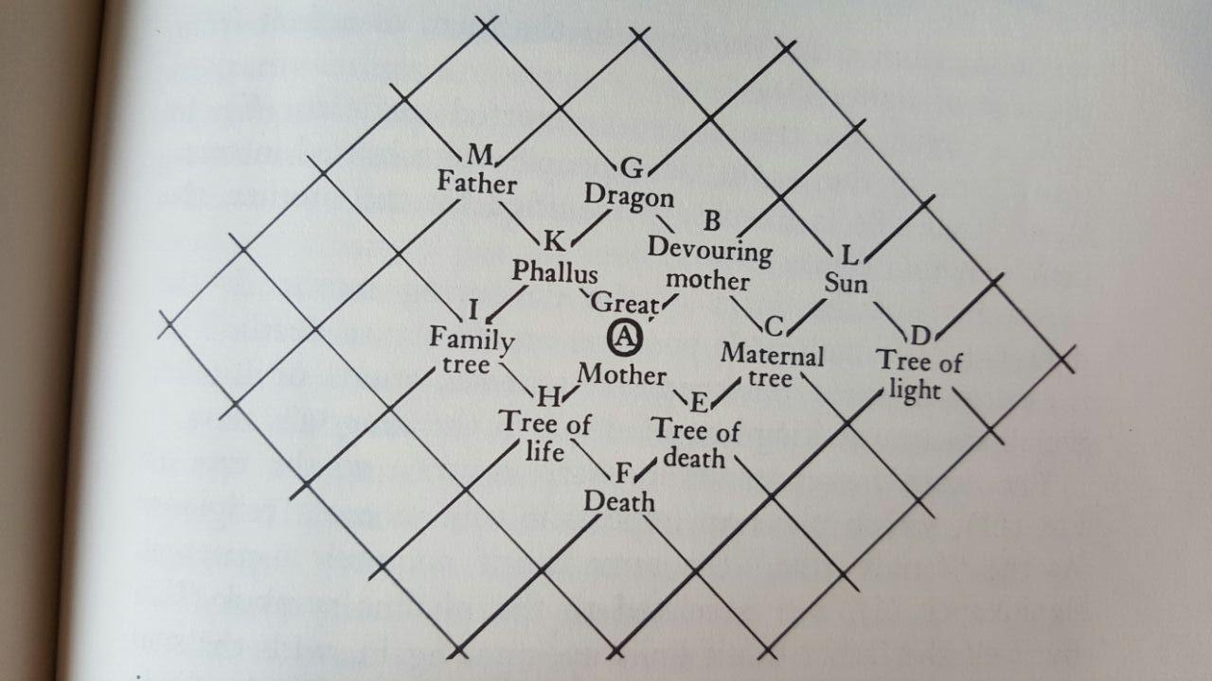

Another form of the Great Mother consists of the maternal tree (C). This form is depicted in the mythic image of the tree whose leaves provide a dwelling place for the souls of unborn children, as well as in all myths about births from trees. The tree in the grave of King Sethos I, from whose breast the king was nourished, is another example.

For its own part, the tree is closely connected with the sun symbol (L). Indeed, according to many myths the sun was born from a tree or hangs in the form of a fruit from the tree of light (D).

As a coffin, the tree is also connected to. death (E). In many parts of the world, dead people were buried in trees. Death itself (F) is likewise personified by the mother, the dark feminine figure (*mors,* fem!).

Another specific form of the devouring mother is the dragon (G) which itself possesses an affinity to death. This is evident in numerous medieval representations of Limbo, which situate the kingdom of death in the dragon’s maw. The death aspect stands in sharp contrast to the tree of life (H), which plays an important role in most religions. As the “family tree,” the same motif acquires a paternal significance (I), and is related to the phallus symbol (K). By itself the father motif links up, once again, with the sun symbol and others, and the phallic motif relates back to the ”Great Mother” who is often characterized by a gigantic nose, a broom, or some other phallic attribute.

These examples of the partial aspects and overlapping meanings an archetypal image is endowed with can be multiplied at will. But the examples given suffice to demonstrate the net of interwoven symbolic images in which, on closer investigation, the archetypes are embedded. In other words, they are contained in a field of inner qualitative nuances. This field may be termed a manifold of psychic contents, whose relations are defined by meaning.

In a fashion similar to certain arrangements in the material realm, groupings in the archetypal sphere that become defective spontaneously and actively take on new forms. The presence of existing structures facilitates the formation of similar complementary or identical representations. The fact that complex structures display a tendency to selectively influence one another, in the formation of similar structures, can also be easily demonstrated.

The “nucleus” of an archetypal field (in our case, the arbitrarily chosen archetype of the Great Mother) is its most imperceptible aspect. Its existence can nevertheless be regarded as consisting of the one that holds together all the other ones. Examining the web in our illustration more closely we might just as well place the archetype of the “sun” at the center of our field of observation, and reestablish from this starting point the identical web of amplifications. **In this way everything archetype forms *the virtual center of a fieldlike realm of representational contents* definable strictly in relative terms, a region overlapping other archetypes.** This structure is also characteristic of natural numbers when they are regarded qualitatively. (pp. 144-147, emphasis mine)

# Advanced: Nucleating Perversion—The Nature of Temporalization

In looking at how the pure archetypal number essences come to be instantiated in specific, neurotic personality traits, there is obviously a lot of filling-in that has to be done by the creative imagination. However, I think that underlying this process is “nucleating” process, in which a living personality fragment grows around a fundamental disconnection (the type of disconnect being archetypally identifiable, like the seed crystal that gives rise to a crystal lattice), and a “perverting” process, by which the energy’s original “intent” is sabotaged and redirected into continual self-sabotage. Going into depth about these processes is beyond the scope of my knowledge and this class, but I wanted to present some intriguing numerological findings which I think support this interpretation.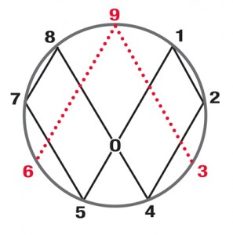

We can compare the official progressions for three systems: the numogram, the enneagram, and vortex math. The diagram on the right is from vortex math, but we can use it for the numogram as well—we flip the numogram upside-down and it fits nicely, with the zones from each syzygy positioned horizontally across the circle from each other. The official progression for both the vortex math system and the numogram’s Time Circuit is 1-2-4-8-7-5 (discussed earlier).

Depicted next is the enneagram’s direction of integration (reverse it to get the direction of disintegration): 1-7-5-8-2-4. We can see that these two progression patterns are almost the same—but what exactly is the difference?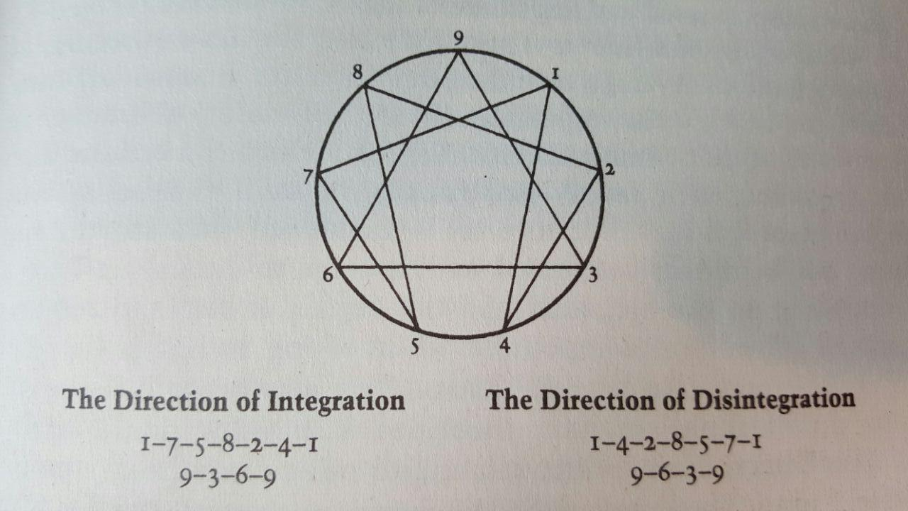

Each zone in the numogram has a polarity: odd numbers are positive and even numbers are negative. If we look at each syzygy on the numogram as a dipole, a single zone with a positive end and a negative end, then we can reconcile these two progression patterns.

The enneagram pattern 1-7-5-8-2-4, traced on the numogram’s Time Circuit, traces out the pole pattern +++---: all the positive (odd) numbers first and then all the negative (even) numbers. Tracing out the numogram’s own pattern (1-2-4-8-7-5) we get +---++: a kind of one-off shift from the other pattern of negative and positive. This shift is suggestive.

Notice that if we simply switch the 1 and the 8 in the numogram’s pattern, we get the enneagram pattern: 1-2-4-8-7-5 becomes 8-2-4-1-7-5 which is the enneagram pattern phase-shifted three places.

In other words, what the enneagram pattern traces is this: a positive loop of three units (the three positive poles of the numogram syzygies, 1-7-5) interlinked with a negative cycle of three units (the three negative poles, 2-4-1)—**two rings which have been linked together into a mobius strip. This connection is made possible because 1 and 8 are switched as origins and destinations of gates/currents/lines of integration. In other words, the numogram traces a path where the “conscious” (positive) and “unconscious” (negative) rings are intermixed, and the enneagram traces a positive ring followed by a negative ring, with the two rings linked back-to-front.**

This allows the enneagram’s official progression to proceed with a bias towards positive/conscious expression, and with a bias towards endless progression/improvement. Meanwhile, the numogram’s intermixed loop denotes more of a stasis and an intermingling of the conscious and unconscious loops. Swapping 1 and 8 closes the enneagram’s circuit, which would otherwise have a gap between the beginning and the end (i.e., it wouldn’t loop).

This design decision, I suggest, represents the enneagram’s focus on personality as opposed to pure archetypal energies. The personality, being fundamentally egoic, has a bias towards the “light”—conscious activity which separates the light from the dark. Meanwhile, the numogram’s focus on the pure plane of number disregards these human/egoic considerations, and constructs a loop which makes no distinction between these realms. The numogram thus focuses more on the pure, archetypal energies.

Both of these tools are useful, and it is interesting to see how their respective official progression patterns represent transforms between the two realms, of egoic/personality and anegoic/archetypal/numeric.

# Conclusion

I hope that these explorations have helped to clarify the distinction between “angel” or “god” and “demon” that is always talked about but rarely specified. In summary, the difference is that what is commonly referred to as a “demon” or “entity” is a nucleated ego fragment based around a certain game or dialectic which grows the fragment according to certain personality-like rules. Whereas, the pure or archetypal energy is unmanifested and thus unconditioned by the requirements to exist and grow in time.

This understanding can be useful in looking at your own patterns and seeing where they are more egoic versus when they are more unrestrained—when your basic impulses are frustrated and perverted versus when you freely express yourself in immediacy. Identifying the core energy of a personality fragment can help to loosen that fragment up and release its unperverted form of energy.

# Further Reading

* [Complex/Archetype/Symbol in the Psychology of C. G. Jung](http://smile.amazon.com/Complex-Archetype-Psychology-Bollingen-General/dp/0691017743?sa-no-redirect=1) by Jolandi Jacobi contains many quotes from Jung that help to articulate his concepts of these three complex terms.
* [Personality Types](http://gen.lib.rus.ec/search.php?req=personality+types+riso+hudson&lg_topic=libgen&open=0&view=simple&phrase=1&column=def) by Riso & Hudson is an in-depth look at the nine enneagram personality types and their implications for personal growth.
* [The Wisdom of the Enneagram](http://smile.amazon.com/The-Wisdom-Enneagram-Psychological-Personality/dp/0553378201?sa-no-redirect=1) by Riso & Hudson is a lighter-weight introduction to the enneagram and the nine types.

1. Programmers will recognize this usage as referring to the distinction between a class definition and an instantiation of that class at runtime. The analogy is exactly apt.
2. For example, this essay [Why I Am No Longer a Lightworker](http://wakeup-world.com/2015/04/26/why-i-am-no-longer-a-light-worker/2/) says: “**Type of Communication is a Major Indicator:**

   The Forces of True Divine Light that exist outside of the corrupt demiurge are not bound by the left-brain right-brain dynamics and dark-light polarities that define the demiurgic sub-universe. This means that they do NOT sound like a voice in your head! Instead, they use “soul telepathy” to emanate feelings, archetypal expressions, and an extremely pure quality of light that speaks directly to your soul.”
3. Some sources say that the etymology of *dæmonic* is “splitting”, and the attribution on the numogram of 2 to ‘dt’ supports this folk etymology. dt→th→dtz→dæ—can you see it? The forked tongue.
4. OCD = Obsessive-Compulsive Disorder and OCPD = Obsessive-Compulsive Personality Disorder. The difference between these two disorders is that in OCPD, the obsessions and compulsions are ego-syntonic—that is, they are aligned with the ego and integrated into the worldview and self-image. “Keeping my house perfectly clean keeps me happy” versus “I have to wash my hands thirty times a day and I can’t stop”. So, the Reformer might (by definition) tend to be identified as OCPD rather than OCD, since their impulses to purify interiors will find a home in their type.
5. For example, what is the difference between splitting an element along a male-female axis and a positive-negative axis? Many people simply (traditionally) equate male = + and female = -, but a much more interesting possibility is placing all four on a compass: + = North, Male = East, - = South, Female = West (this matches the numogram, roughly—but other arrangements could be imagined).